1. Login to sonar cloud with azure Devops credentials

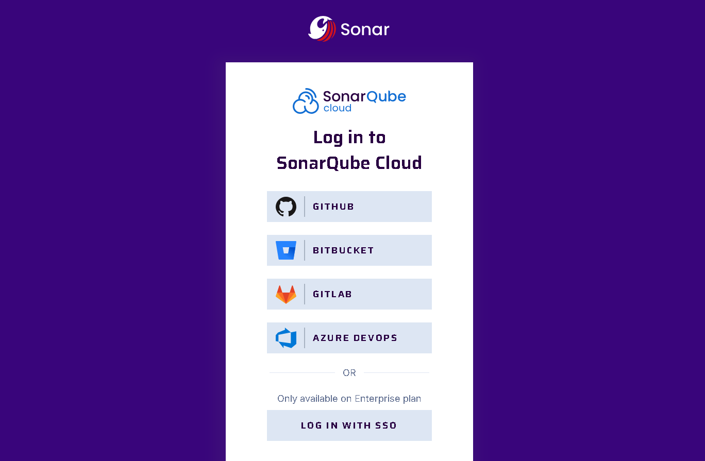

1. Once login to sonar cloud you should see following screen

1. Click on right ( + ) icon and create new organisation in sonar cloud

1. Click on Import from Devops platform

1. Provide your azure Devops organisation name, create and provide PAT in azure Devops which should have on code (Read and write) access and click on continueA screenshot of a computer

   Description automatically generated
2. Import organisation details

1. Finally click on create organisation and that will create organisation in sonar cloud.
2. Click on Analyze new project and it will allow you to import only public project from your Devops organisation. Select repo from project and click on setup.
3. In your pipeline include following details

